IP Camera
Home/ Office CCTV Surveillance
Made Easy

DYN-700

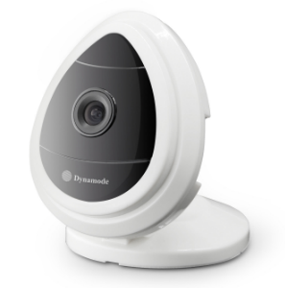

DESCRIPTION
The exciting DYN-700 Smartphone-ready wireless IP camera is your ideal security partner for home or office. Forget messy, complex setups, the DYN-700 can be setup in just a few minutes from your smartphone, tablet or computer - WindowsTM, MacTM or AndroidTM.
Superb HD colour display, watch in both daylight and total darkness and get an email when
motion is detected, the choice is yours 24/7.

FEATURES
- HD, Colour CMOS with multi-coated optics
- HD 1-Megapixel capturing with 3.6mm lens
- Instant setup - No messy router setups needed
- HD quality audio with built-in microphone
- Supports up to 720p, 360p and 180p resolutions
- Built-in super fast 802.11n WiFi (b/g supported)
- Motion detection alarm setup
- Supports multi-view display for multiple IP cameras
- Multi- language support with free client software

SPECIFICATIONS
Model | 700GC
Hardware performance | Product type | IP camera
 | Operation system | Embedded operating system
 | Special function | One key WIFI setting, no need network cable
Web environment | Web protocol | TCP/IP, UDP/IP, HTTP, SMTP, FTP, DHCP, DDNS, UPNP, NTP, RTSP, ONVIF
 | Wifi | WIFI, 802.11 b/g/n
Image performance | Resolution | 720P, 640*360, 320*180
 | Compression mode | H.264/M-JPEG
 | Max frame rate | 30fps
Other parameters | Lens | f=3.6mm, F=2.0
 | Min. illumination
 | Electronic shutter | 1/50s(1/60s)-1/100,000 s
 | SNR | 48db
 | Safety performance | Three levels of user rights
 | Install mode | Wall-mounted / ceiling-mounted
 | Other performance | PC software,support for Microsoft Windows 98/2000/XP/Vista/Windows 7/Mac OS,And the Internet Explorer6.1 and above version or browser compatibility, Firefox, etc.,  provide iSmartViewPro client software
 | Power supply | DC 5V
 | Sensor | 1/4’’ CMOS Sensor
 | IP camera performance | Support video control, motion detection, external alarm(sends information to alarm the server by Email, FTP);
 | Audio input | With microphone
 | Audio output | Not supported
 | Alarm in | Not supported
 | Alarm out | Not supported
 | Power consumption | Power<4W
Appearance parameters | Body size | 66*44.5*76.5mm
 | Product weight | 0.104kg
Environment parameters | Environment temperature | -10℃-50℃
 | Environment humidity | below 85% RH

Packing List
- 1, IP Camera* 1
- 2, Quick installation Guide* 1
- 3, Power Adapter *1
- 4, Screw*1kit
- 5, Certificate of qualification*1

